Functional Document

1. Introduction
The Hostel Complaint Management System is a web-based application designed to streamline the process of lodging, tracking, and resolving complaints within hostel premises. The system enables students to register complaints easily and allows hostel authorities to manage and resolve them efficiently.It replaces manual complaint registers with a digital platform, improving transparency, accountability, and response time.

2. Product Goal
The main goals of the system are:
- To provide a centralized platform for complaint registration
- To ensure quick and transparent resolution of issues
- To reduce manual effort and paperwork
- To enable real-time tracking of complaint status
- To improve communication between students and hostel administration

3. Demography (Users, Location)

Users:
- Students
  - Register complaints
  - Track complaint status
  - View complaint history
- Admin / Hostel Authorities
  - View all complaints
  - Assign complaints to staff
  - Update complaint status
  - Manage users
- Maintenance Staff (optional role)
  - View assigned complaints
  - Update resolution progress

Location:
- Designed for use within college hostel premises
- Accessible via web browser (can be extended to mobile)

4. Business Processes
- User Registration & Login
  - Students register/login using email
  - Authentication handled via backend (e.g., Supabase)
- Complaint Submission
  - Student fills complaint form (category, description, hostel block, etc.)
  - Complaint is stored in database
- Complaint Assignment
  - Admin reviews complaint
  - Assigns to relevant department/staff
- Complaint Tracking
  - Status updates: Pending → In Progress → Resolved
- Resolution & Feedback
  - Admin marks complaint as resolved
  - Student can view status and optionally give feedback

5. Features

5.1 Feature #1: Complaint Registration

1. Description
Allows students to submit complaints related to hostel facilities such as electricity, water, cleanliness, internet, etc.

2. User Story
As a student, I want to submit a complaint easily so that my issue can be addressed quickly.

5.2 Feature #2: Complaint Tracking

1. Description
Students can view the status of their complaints in real-time.

2. User Story
As a student, I want to track my complaint status so that I know when it will be resolved.

5.3 Feature #3: Admin Dashboard

1. Description
Admin can view all complaints, filter them, assign tasks, and update statuses.

2. User Story
As an admin, I want to manage all complaints efficiently so that issues are resolved on time.

5.4 Feature #4: Status Management

1. Description
Admin/staff can update complaint status (Pending, In Progress, Resolved).

2. User Story
As staff, I want to update complaint progress so that students stay informed.

5.5 Feature #5: Authentication System

1. Description
Secure login/signup system for users.

2. User Story
As a user, I want a secure login so that my data is protected.

6. Authorization Matrix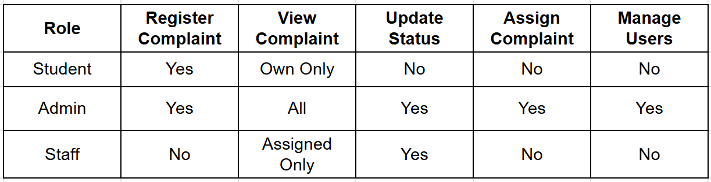

7. Assumptions
- All users have internet access
- Students will use valid college email IDs
- Admin has full control over complaint handling
- System is used within a controlled hostel environment
- Database (e.g., Supabase/MySQL) is properly configured
- Users will provide accurate complaint details

